|  |
| --- |
| **National University of Computer and Emerging Sciences** |
| In-Lab 6 Exercise  “Views” |
|  |
| Database Systems |
| Spring 2023 |

Department of Computer Science

FAST-NU, Lahore, Pakistan

**Total Time: 60 Minutes**

**Schema:**

Schema is given in InLab6OrderCustomerSchema.sql file.

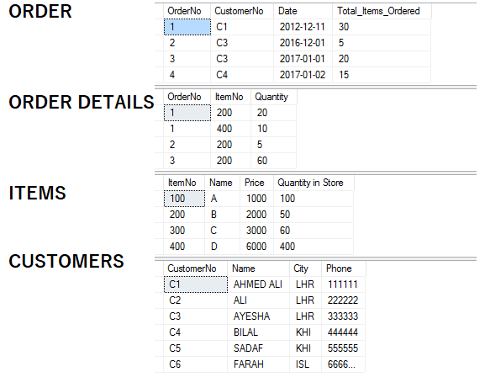

**Exercise for Views:**

1. Create a view that gives order number and total price of that order where total price is equal to item price multiplied by item quantity of that order.
2. Create a view that gives all the items that are doing well in sales. The criteria to judge which item is doing good sale is that the item is has sold more than 20 pieces.
3. Create a view that returns star customers. Star customers are the customers that have made a purchase of more than 2000.
4. Create a view that returns all the customers that have phone number not null WITHOUT WITH CHECK option. Also, create a view with WITH CHECK option. Now, try to insert, delete and update through the view, and observe the results.